Exploratory Data Analysis on International Breweries Sales Data Using SQL

*Getting every item in the table*

SELECT

*

FROM

international_breweries;

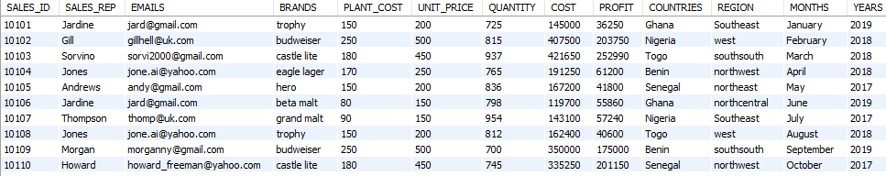

SESSION A (PROFIT ANALYSIS)

1. Within the space of the last three years, what was the profit worth of the breweries, inclusive of the anglophone and the francophone territories?

SELECT

SUM(profit) AS Total_Profit

FROM

international_breweries;



The total profit made within these three years of operation was approximately 105 million.

1. Compare the total profit between these two territories for the territory manager, Mr. Stone, to make a strategic decision that will aid profit maximization in 2020.

SELECT

CASE

WHEN COUNTRIES in ('Ghana', 'Nigeria') THEN 'Anglophone'

WHEN COUNTRIES in ('Togo', 'Benin', 'Senegal') Then 'Francophone'

ELSE 'Unknown'

END AS Territory,

SUM(PROFIT) AS TotalProfit

FROM

international_breweries

GROUP BY

Territory;

The Francophone region had the highest profit within the three years of operation.

1. What country generated the highest profit in 2019?

SELECT

countries, SUM(profit) AS total_profit

FROM

international_breweries

GROUP BY countries

ORDER BY total_profit DESC;

Senegal generated the highest profit of about 21 million, Togo generated the lowest profit of about 20 million.

1. Help him find the year with the highest profit.

SELECT

YEARS, SUM(profit) AS total_profit

FROM

international_breweries

GROUP BY YEARS

ORDER BY total_profit DESC;

Among the three years 2017 outperformed 2018 and 2019 in terms of profit generation

1. Which month in the three years was the least profit generated?

SELECT

MONTHS, SUM(profit) AS total_profit

FROM

international_breweries

GROUP BY MONTHS

ORDER BY total_profit ASC;

The month of April generated the least profit across the three-year period.

1. What was the minimum profit in the month of December 2018?

SELECT

MONTHS, MIN(PROFIT) AS minimum_profit

FROM

international_breweries

WHERE

YEARS = 2018 AND MONTHS = 'December'

GROUP BY MONTHS;



The minimum profit made in December 2018 was 38,150.

1. Compare the profit for each of the months in 2019.

SELECT

MONTHS, SUM(PROFIT) AS total_profit

FROM

international_breweries

WHERE

YEARS = 2019

GROUP BY MONTHS

ORDER BY total_profit DESC;

The month of July generated the highest profit in the year of 2019 while,

February generated the least.

1. Which brand generated the highest profit in Senegal?

SELECT

brands, SUM(profit) AS total_profit

FROM

international_breweries

WHERE

countries = 'Senegal'

GROUP BY brands

ORDER BY total_profit DESC;

Castle lite is the golden brand in Senegal and generated the highest profit.

SESSION B (BRAND ANALYSIS)

1. Within the last two years, the brand manager wants to know the top three brands consumed in the francophone countries.

SELECT

BRANDS,

CASE COUNTRIES

WHEN COUNTRIES in ('Ghana', 'Nigeria') THEN 'Anglophone'

WHEN COUNTRIES in ('Togo', 'Benin', 'Senegal') Then 'Francophone'

ELSE 'Unknown'

END AS Territory,

SUM(PROFIT) AS TotalProfit

FROM

international_breweries

WHERE

YEARS <> 2017

GROUP BY Territory , BRANDS

HAVING Territory = 'Francophone'

ORDER BY TotalProfit DESC

LIMIT 3;

In this order Budweiser, castle lite, and eagle lager were the top three brands in francophone countries.

1. Find out the top two choice of consumer brands in Ghana.

SELECT

BRANDS, SUM(QUANTITY) AS total_Quantity

FROM

international_breweries

WHERE

COUNTRIES = 'Ghana'

GROUP BY BRANDS

ORDER BY total_Quantity DESC

LIMIT 2;

In Ghana, the top two choices are eagle lager and castle lite.

1. Find out the details of beer consumed in the past three years in the most oil reached country in West Africa.

SELECT

*

FROM

international_breweries

WHERE

COUNTRIES = 'Nigeria';

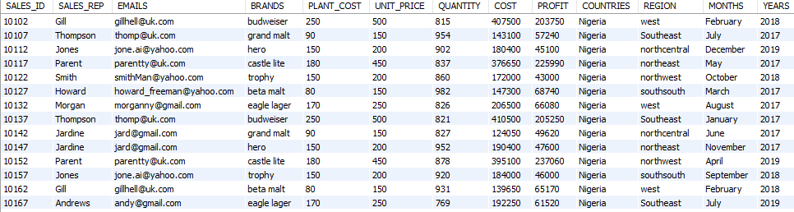

SELECT DISTINCT

BRANDS, UNIT_PRICE, PLANT_COST

FROM

international_breweries

GROUP BY BRANDS, UNIT_PRICE, PLANT_COST

ORDER BY PLANT_COST DESC;

SELECT

brands, SUM(profit) as total_profit, SUM(quantity) as total_quantity

FROM

international_breweries

GROUP BY brands

ORDER BY SUM(profit) DESC;

There are 7 different brands in Nigeria, Budweiser had the highest UNIT_PRICE and PLANT_COST. Castle lite generated the highest profit, and consequently had the highest unit sold.

1. Favorites malt brand in Anglophone region between 2018 and 2019

SELECT

BRANDS,

CASE COUNTRIES

WHEN COUNTRIES in ('Ghana', 'Nigeria') THEN 'Anglophone'

WHEN COUNTRIES in ('Togo', 'Benin', 'Senegal') Then 'Francophone'

ELSE 'Unknown'

END AS Territory,

SUM(PROFIT) AS TotalProfit

FROM

international_breweries

WHERE

BRANDS LIKE '%malt'

AND YEARS BETWEEN 2018 AND 2019

GROUP BY Territory, BRANDS

HAVING Territory = 'Anglophone'

ORDER BY TotalProfit DESC;

Beta malt is the favourite brand in Anglophone region.

1. Which brands sold the highest in 2019 in Nigeria?

SELECT

BRANDS, SUM(QUANTITY) AS total_quantity

FROM

international_breweries

WHERE

COUNTRIES = 'Nigeria' AND YEARS = 2019

GROUP BY BRANDS

ORDER BY total_quantity DESC

LIMIT 1;



Hero sold the highest in 2019 in Nigeria.

1. Favorites brand in South_South region in Nigeria

SELECT

BRANDS, SUM(QUANTITY) AS total_quantity

FROM

international_breweries

WHERE

COUNTRIES = 'Nigeria'

AND REGION = 'southsouth'

GROUP BY BRANDS

ORDER BY total_quantity DESC

LIMIT 1;



In the south south region of Nigeria eagle lager is the favourite brand

1. Beer consumption in Nigeria

SELECT

SUM(QUANTITY) AS total_quantity_consumed

FROM

international_breweries

WHERE

COUNTRIES = 'Nigeria'

AND BRANDS NOT LIKE '%malt';



129,260 units of beer was consumed in Nigeria with these three years.

1. Level of consumption of Budweiser in the regions in Nigeria

SELECT

SUM(QUANTITY) AS total_quantity_consumed

FROM

international_breweries

WHERE

COUNTRIES = 'Nigeria'

AND BRANDS = 'Budweiser';



SELECT

REGION, SUM(QUANTITY) AS total_quantity_consumed

FROM

international_breweries

WHERE

COUNTRIES = 'Nigeria'

AND BRANDS = 'Budweiser'

GROUP BY REGION

ORDER BY total_quantity_consumed DESC;

In Nigeria 26,153 units of Budweiser was consumed within 2017, 2018 and 2019.

with western region accounting for the highest amount

1. Level of consumption of Budweiser in the regions in Nigeria in 2019 (Decision on Promo)

SELECT

SUM(QUANTITY) AS total_quantity_consumed

FROM

international_breweries

WHERE

COUNTRIES = 'Nigeria' AND YEARS = 2019

AND BRANDS = 'budweiser'

ORDER BY total_quantity_consumed DESC;

SELECT

REGION, SUM(QUANTITY) AS total_quantity_consumed

FROM

international_breweries

WHERE

COUNTRIES = 'Nigeria' AND YEARS = 2019

AND brands = 'Budweiser'

GROUP BY REGION

ORDER BY total_quantity_consumed DESC;

5490 units of Budweiser was consumed in Nigeria in 2019 alone, southeastern region had the highest amount of 1,821.

SESSION C (COUNTRIES ANALYSIS)

1. Country with the highest consumption of beer.

SELECT

COUNTRIES, SUM(QUANTITY) AS total_quantity

FROM

international_breweries

WHERE

brands NOT LIKE '%malt'

GROUP BY COUNTRIES

ORDER BY total_quantity DESC;

Senegal had the highest consumption of beer.

1. Highest sales personnel of Budweiser in Senegal

SELECT

SALES_REP,

SUM(QUANTITY) AS total_quantity,

SUM(PROFIT) AS total_profit

FROM

international_breweries

WHERE

COUNTRIES = 'Senegal'

GROUP BY SALES_REP

ORDER BY total_quantity DESC;

In Senegal, Jones sold the highest quantity and generated the highest profit.

1. Country with the highest profit of the fourth quarter in 2019

SELECT

COUNTRIES,

SUM(PROFIT) AS total_profit

FROM

international_breweries

WHERE

YEARS = 2019

AND (MONTHS = 'October' OR MONTHS = 'November' OR MONTHS = 'December')

GROUP BY

COUNTRIES

ORDER BY

total_profit DESC;

In the fourth quarter of 2019, Ghana generated the highest profit while, Senegal generated the least profit